Review of a book “The Lord of the Rings”

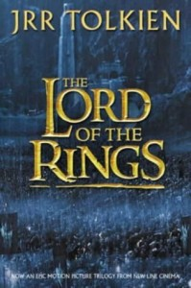”Not all those who wonder are lost”

"The Lord of the Rings" is a book by the eminent English writer John Ronald Reuel Tolkien. This is a fantastic novel, which takes place in a fictional world called Middle-earth. This place is inhabited by Hobbits – creatures similar to human beings, but much smaller. Author with a great passion shows their habits and customs . The Lord of the Rings is an entity named Sauron, the Dark Lord, who long ago lost the One Ring that contains much of his power. His overriding desire is to reclaim the Ring and use it to enslave all of Middle-earth. There are also other, equally interesting, fantastic creatures, which play a greater or lesser roles in the plot.
The main character of the novel is a Hobbit named Frodo. He is always accompanied by his faithful friend, Sam. Frodo inherits his uncle mysterious ring, which he can use to become invisible. Once he learns more about the past of this precious treasure. It turns out that this is a ring forged by Sauron, the Dark Lord, who wanted to take control of the world. However, he was defeated, and the treasure was lost for thousands of years.
Later in the story, Frodo and Sam set off on their journey with the ring to the Rivendell – the mystical, beautiful city of elves. There is a council, which is elected to take the ring to Mordor - the place where it was forged. Only here they can destroy it in order to avoid destruction of the world. As it turns out, the mission is dangerous and challenging. At each step of the book, we can observe compensated struggle between good and evil.
Reading this book gave me a great pleasure, therefore, I recommend it to all fans of history, fantasy and suspenseful stories.

Michał Stępień
Class I „c”
