Review of a book “The Hobbit”

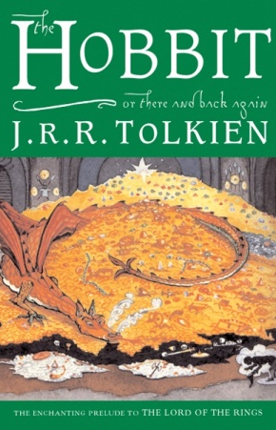 “The morning often gives advice, and night often changes the mind.”

The Hobbit by J.R.R.Tolkien was first published in Great Britain in 1937. It was published just before the outbreak of WWII in Europe. The Hobbit is the story of Bilbo Baggins, a hobbit who lives in Hobbiton. A Hobbit is a small creature half the size of a man. They have no beards and hairy feet with a tendency for rotund stomachs. They tend to be farmers and rarely go on adventures. Beyond the borders of their people, few have ever heard of them.
Bilbo enjoys a peaceful and pastoral life but his life is interrupted by a surprise visit by the wizard Gandalf. Before Bilbo is able to improve upon the situation, Gandalf has invited himself to tea and when he arrives, he comes with a company of dwarves led by Thorin. They are embarking on a journey to recover lost treasure that is guarded by the dragon Smaug, at the Lonely Mountain. Gandalf has decided, much to Bilbo’s chagrin, that the hobbit will make an excellent addition to the team and Bilbo is going to play the role of a burglar. As they start on their way, Bilbo has serious misgivings. On the journey, Bilbo and the dwarves encounter all sorts of villains and obstacles. His adventures, are like stepping stones on the inner journey Biblo must take to find his courage. Bilbo faces trials which again and again force him to look deep inside himself for the strength and resourcefulness he needs to complete the task expected of him. After a very long journey, Bilbo makes it home to find his stuff being auctioned off. He gets most of his things back and settles down again, happy to be living a simple life after so long a tale.
In my opinion this book is fantastic. It is really worth reading for everyone, who likes adventure novels. I recommend it to all teenagers who want to escape from the real world.
Mariusz Zagórski
Class I „c”
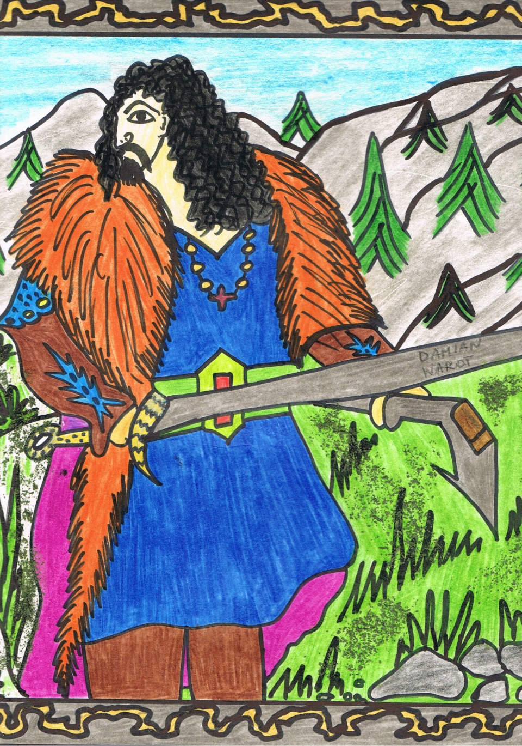

Review of a book “The Catcher in the Rye”

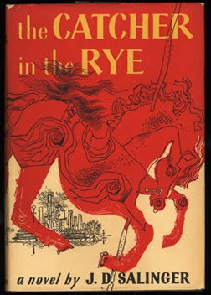 “For the immature man is significant that he wants to die nobly for a cause, while the mature - that he wants to live humbly for her.”
The Catcher in the Rye, written by J.D. Salinger is set around the 1950s and is narrated by a young man named Holden Caulfield. Confused and disillusioned, he searches for truth. Holden is not specific about his location while he’s telling the story, but he makes it clear that he is in a mental hospital or sanatorium. The events he narrates take place in the few days between the end of the fall school term and Christmas, when Holden is sixteen years old.
Holden’s story begins on the Saturday following the end of classes at the Pencey prep school in Agerstown, Pennsylvania. Pencey is Holden’s fourth school. He has already failed out of three others. At Pencey, he has failed four out of five of his classes and has received notice that he is being expelled, but he is not scheduled to return home to Manhattan until Wednesday. He visits his elderly history teacher, Spencer, to say goodbye, but when Spencer tries to reprimand him for his poor academic performance, Holden becomes annoyed. He tells us also that the one thing he would like to be is the catcher in the rye. He would stand near the edge of a cliff, by a field of rye, and catch any of the playing children who, in their abandon, come close to falling off. Holden ends his narrative, telling the reader that he is not going to tell the story of how he went home and got sick. He plans to go to a new school in the fall and is cautiously optimistic about his future.
I think that, this is an excellent book for young readers, lost and rebellious. The novel covers a period of adolescence, puberty, forming their own views of the world, for themselves and other people. The writer showed typical teenage rebellion, but also honesty. I recommend this book very much.
Tomasz Woźniczka
Class III „c”

