Review of a book “The Little Prince”

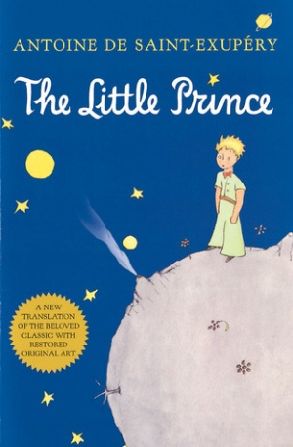 “The most beautiful things in the world
cannot be seen or touched, they are felt with the heart.”

“The Little Prince” is the most popular of the books written by Antoine de Saint-Exupery. It was published in 1943. In a short time, the book was a great success and the French writer became famous. People came to love the Exupery's story. It was translated to a lot of languages, published in hundreds countries and in millions copies worldwide, making it one of the best-selling books ever published. The story of the Little Prince went round all over the world and it is still very popular.
With a timeless charm it tells the story of a little boy from Asteroid B-612. The protagonist is a simple, mystical, creature. One day a seed arrives on his planet and blooms into a beautiful flower. Though the flower is lovely, it is vain and irritates the Prince. Finally he leaves his planet, to escape the flower. After visiting several asteroids, the Little Prince reaches Earth, where he meets the narrator in the Sahara Desert. His adventures on six different planets are recounted, including the encounters with the king, the vain man, the drunkard, the businessman, the lamplighter, the geographer, the snake, the fox, and the narrator. He visits many planets and meets many people, whom he questions about life. In particular, he wants to understand the existence and pastimes of adults on Earth. He tries to find his answers from a snake, a fox, and the narrator.
The story ends when The Little Prince finds the answers to his questions about what is important in life. When he realizes his love for the flower, he accepts that he must return to his star to care for the rose. He makes arrangements with the poisonous snake to bite him.
For me it is a charming story about amazing friendship between two people - an adult pilot, and a little boy. In the Little Prince’s stories we can see the truth about ourselves. He has learned from the fox that the important things in life cannot be seen with the eye, only felt with the heart. In the book, Saint-Exupéry explains the importance of true friendship, relationships and what is essential in life. For children it is beautiful, interesting and funny tale about the boy who looks a friend. For adults, short, well-written story about themselves. Therefore, this is the book good for everybody, everywhere and in every age. I truly recommend it and I promise that you will never regret reading.

Katarzyna Prusek
Class II „a”
