Review of a book “A Christmas Carol”

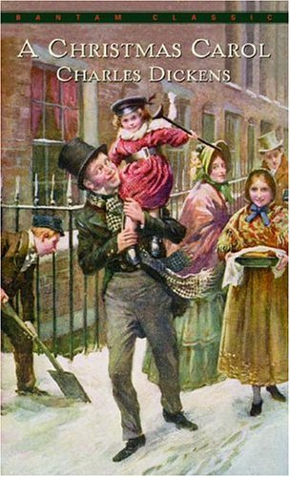 “There is nothing in the world so irresistibly
contagious as laughter and good humor.”

Last Sunday I read a novel “A Christmas Carol” by Charles Dickens. He wrote this book in 1843 in Great Britain during Christmas Eve. The book was written and published in early Victorian Era Britain. A ghost story, moral lesson, this is one of Dickens’ best known and loved tales.
It is a story about a sour man, who was very mean but after that he became a good person. This book shows the struggle of an old insensitive man taken on a voyage of his life. The voyage is in order to save him from a dreary after life. The main character is Ebenezer Scrooge, an old merchant. He is a hard-heartened old businessman, who hates Christmas. Ebenezer is a very gloomy and cruel character who doesn’t have any friends and thinks only about his own life. He is an egoist. During Christmas Eve three spirits visited him. They showed to Ebenezer his mistakes and his future. Then Ebenezer udnerstood what he did and he became a good person. He realized that money is not the most important thing in life. He became a nice and friendly man.
I think it is a great, well-written and interesting book .This novel teaches us how we should live. You should read this book. It is fantastic.

Magdalena Ligorowska
Class II „c”

